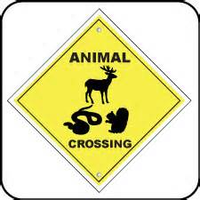
[Insert Company Name]
The Professional Driver’s Current Information Source
The Communiqué

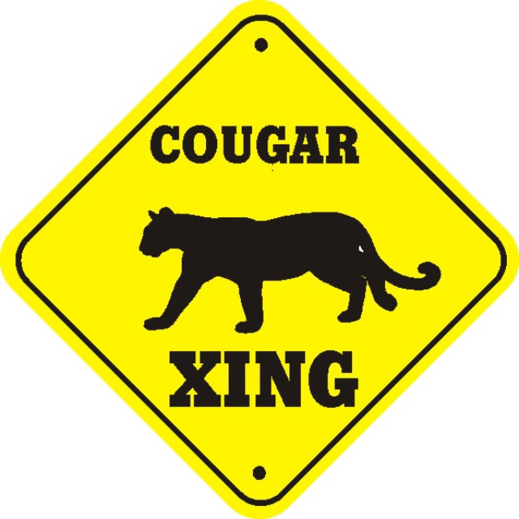
It’s Not Just About the Deer! Wildlife Xing Accident Countermeasures
The Communiqué® is a trademarked publication created by Professional Safety Consulting, Inc., available exclusively to PSC Insiders Circle members. Redistribution to non-members is strictly prohibited. Members have acknowledged these terms. The Communiqué® is advisory in nature and does not warrant, guarantee, or otherwise certify compliance with laws, regulations, requirements, or guidelines of any local, state, or Federal agency and/or governing body, or industry standards.
The Communiqué® is a trademarked publication created by Professional Safety Consulting, Inc., available exclusively to PSC Insiders Circle members. Redistribution to non-members is strictly prohibited. Members have acknowledged these terms. The Communiqué® is advisory in nature and does not warrant, guarantee, or otherwise certify compliance with laws, regulations, requirements, or guidelines of any local, state, or Federal agency and/or governing body, or industry standards.
The Communiqué® is a trademarked publication created by Professional Safety Consulting, Inc., available exclusively to PSC Insiders Circle members. Redistribution to non-members is strictly prohibited. Members have acknowledged these terms. The Communiqué® is advisory in nature and does not warrant, guarantee, or otherwise certify compliance with laws, regulations, requirements, or guidelines of any local, state, or Federal agency and/or governing body, or industry standards.
The Communiqué® is a trademarked publication created by Professional Safety Consulting, Inc., available exclusively to PSC Insiders Circle members. Redistribution to non-members is strictly prohibited. Members have acknowledged these terms. The Communiqué® is advisory in nature and does not warrant, guarantee, or otherwise certify compliance with laws, regulations, requirements, or guidelines of any local, state, or Federal agency and/or governing body, or industry standards.
The Communiqué® is a trademarked publication created by Professional Safety Consulting, Inc., available exclusively to PSC Insiders Circle members. Redistribution to non-members is strictly prohibited. Members have acknowledged these terms. The Communiqué® is advisory in nature and does not warrant, guarantee, or otherwise certify compliance with laws, regulations, requirements, or guidelines of any local, state, or Federal agency and/or governing body, or industry standards.

The National Highway Traffic Safety Administration (NHTSA) estimates there are approximately 1.5 million vehicle/deer collisions annually, resulting in property damage in excess of $1.5 billion. That averages out to $1,000 per deer strike. On average 200 of those collisions result in a human fatality, drivers have to be on alert and know what to do when confronting animals.

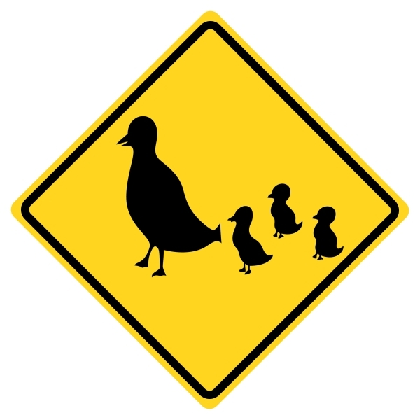
To avoid an accident, heed posted warning signs. States post Deer/Wildlife crossing signs on highways that traverse prime habitats such as forested and pasture areas abutting tree lines. If you see these posted signs, be alert and slow down. Wildlife crosses the roads for many reasons, at different times of the year; often they want to get to another part of their habitat. For deer rutting and hunting seasons cause more movement on the roads. Fall season is when a number of these wildlife strikes spike. Especially during sunrise and sunset hours, the hardest time for driver eyes to adjust to the light and recognize road hazards. The slower the driver goes the greater the reaction time to avoid a collision. Wildlife experts recommend 55 MPH as a suitable speed in wildlife zones during good weather conditions.

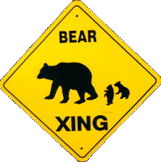
Defensive driving is being prepared to take evasive action including being able to slow down safely. Drive so the vehicle is able to stop within the distance of the headlight beam. Make sure seatbelts are worn by the driver and passengers. When traveling through posted wildlife zones, drivers must keep their eyes moving along the sides of the road, especially shoulders, ditches, center medians and intersecting roads to spot any movement, eye reflections or body shapes. If a deer or any other animal is spotted, laying on the horn or flashing the lights is more likely to terrify the animal than scare it away. In terror, the deer will be more likely to dart into the vehicle’s travel path and Bucks have been known to charge vehicles during rutting season. If an animal suddenly appears in front of the vehicle, brake firmly. DO NOT SWERVE causing the vehicle to leave the travel lane. Many accidents are not due to hitting the animal, but are due to colliding with an oncoming vehicle in the opposite lane or the driver losing control of the vehicle; leaving the road surface. The best defense is to go slow, increase the vehicle’s stopping distance and avoid the collision with timely braking.
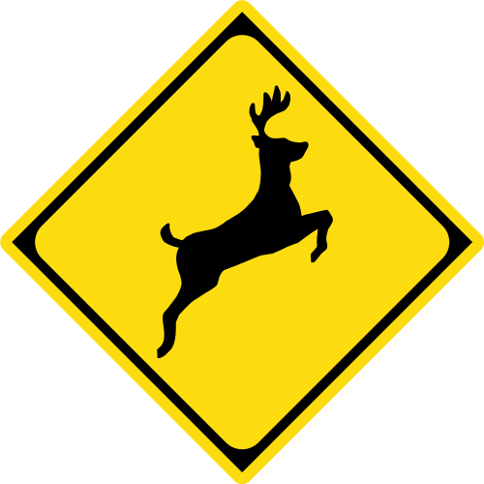
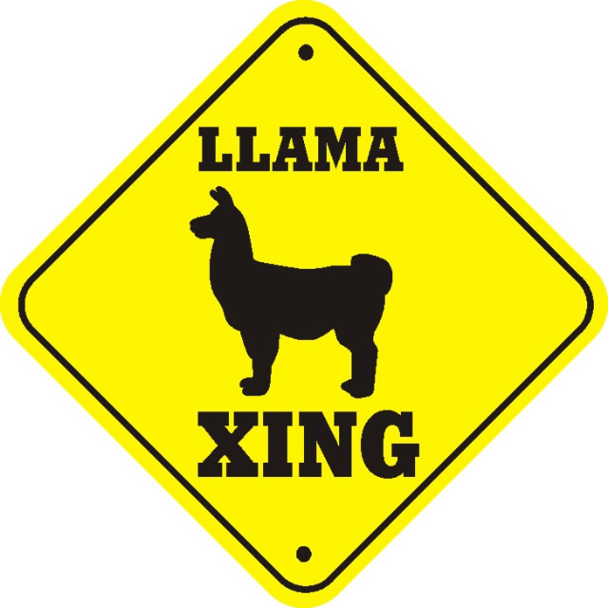
If a collision is inevitable, the driver needs to lessen the impact. Try to brush the animal rather than hit it full force. Brake firmly, angle the vehicle with the driver taking their foot off the brake at impact. This brake release will cause a slight lift of the vehicle being enough to keep the animal from rolling onto the hood into the windshield. After the collision, pull over, turn on emergency flashers, and if possible, direct the headlights onto the animal or get as close as possible. If passengers are in the vehicle, check for injuries and treat accordingly. Avoid going near the animal as it may try to kick or gore from fear and pain. If the animal is blocking the road, use hazard lights and/or flares alerting other vehicles. Only attempt to remove the animal if it is dead. Call 911 and/or flag down vehicles for assistance. Keep in mind that most insurance companies will not pay damage claims unless there is a filed police report.

